class Cat:

def __init__(self,color,legs):

self.color=color

self.legs=legs

def __str__(self):

return self.color +','+str(self.legs)

if __name__=="__main__":

pet1=Cat("ginger",4)

print(pet1.legs)

print(pet1.color)

print(pet1)

pet2=Cat("brown",3)

print(pet2.color)

print(pet2.legs)

print(pet2)

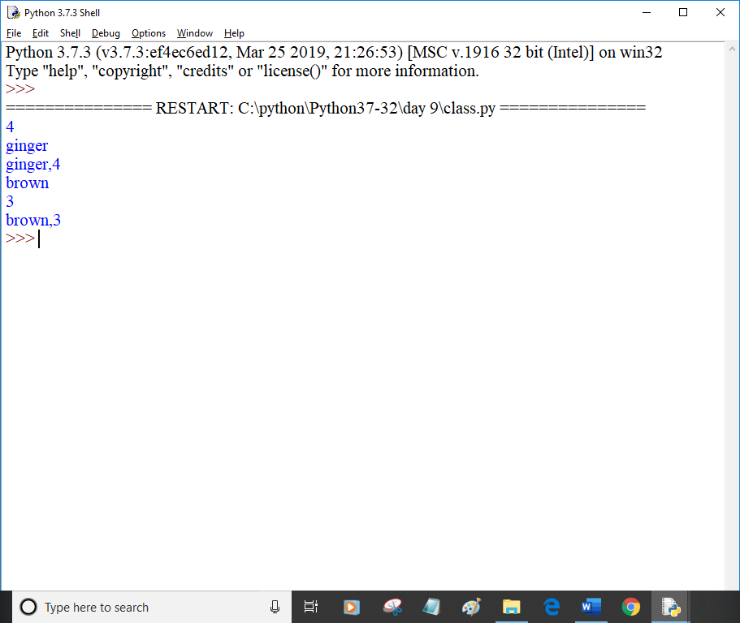

class Wolf:

price=500

def __init__(self,name,color):

self.name=name

self.color=color

def bark(self):

print("Grr...")

class Dog(Wolf):

def bark1(self):

print("Woof")

if __name__=="__main__":

pet1=Dog("tomy","brown")

pet1.bark()

pet1.bark1()

print(pet1.name,"is of colour",pet1.color)

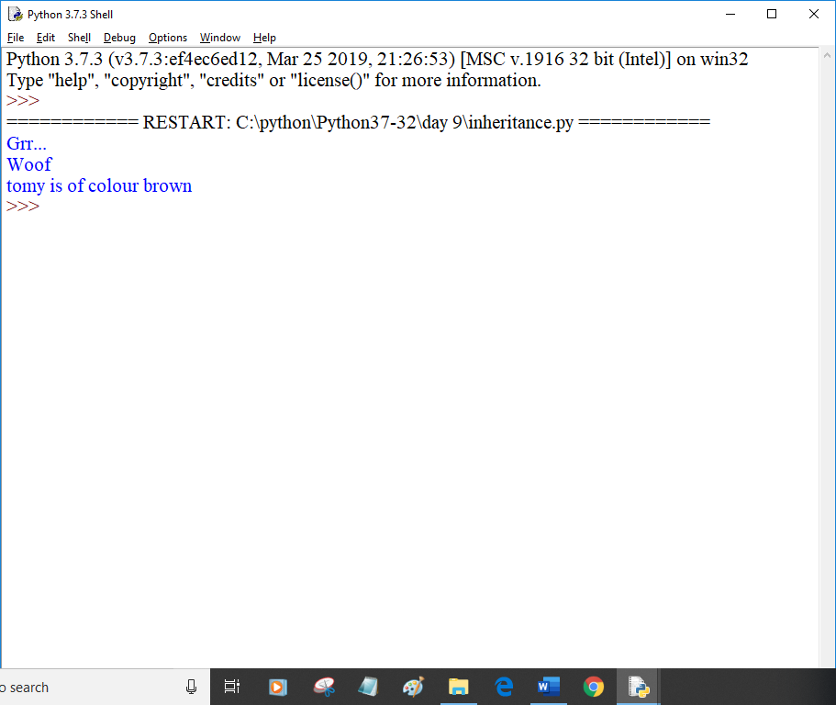

class Animal:

def __init__(self,name,color):

self.name=name

self.color=color

class Cat(Animal):

def mew(self):

print("Cat meows")

class Dog(Animal):

def bark(self):

print("Woof")

if __name__=="__main__":

pet1=Dog("tomy","brown")

pet2=Cat("lucy","white")

pet1.bark()

pet2.mew()

print(pet1.name)

print(pet2.name)

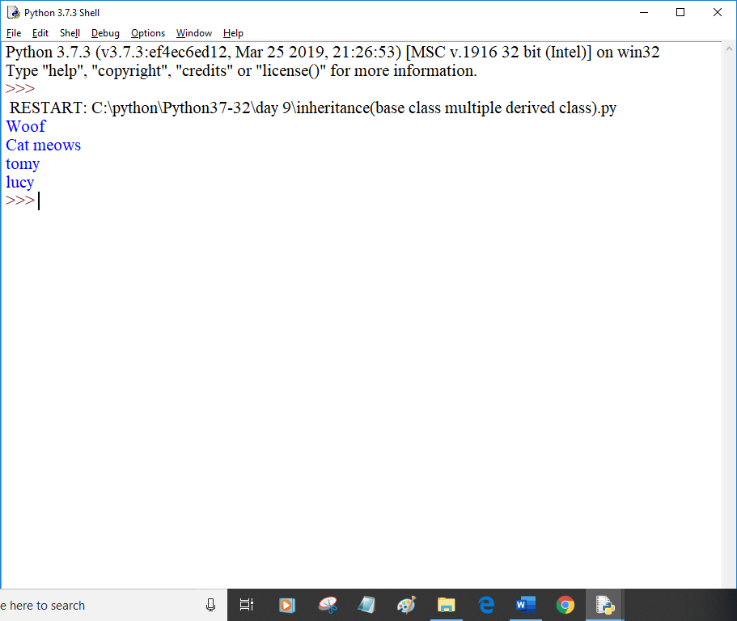

class Wolf:

def __init__(self,name,color):

self.name=name

self.color=color

def bark(self):

print("Grr..")

class Dog(Wolf):

def bark(self):

print("Woof")

pet1=Dog("tomy","brown")

pet1.bark()

pet2=Wolf("jimmy","grey")

pet2.bark()

Dog("abc","xyz").bark()

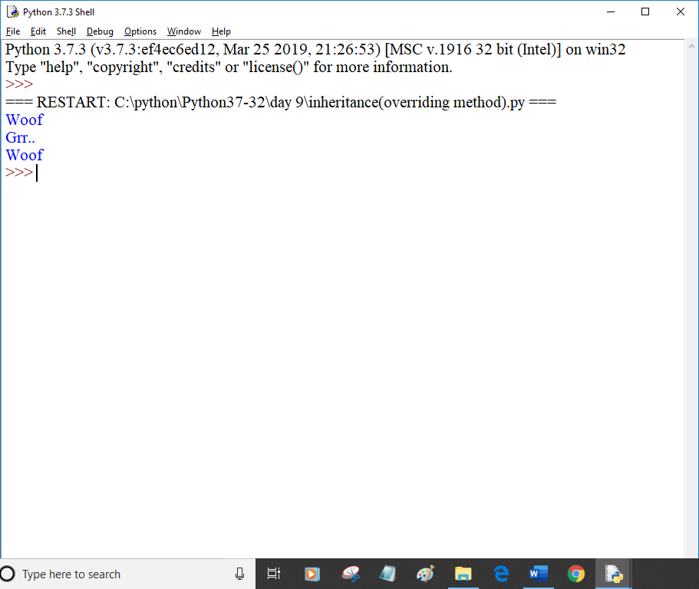

class A:

def first_method(self):

print("Method of class A...")

class B(A):

def second_method(self):

print("Method of class B...")

class C(B):

def third_method(self):

print("Method of class C...")

if __name__=="__main__":

ob=C()

ob.first_method()

ob.second_method()

ob.third_method()

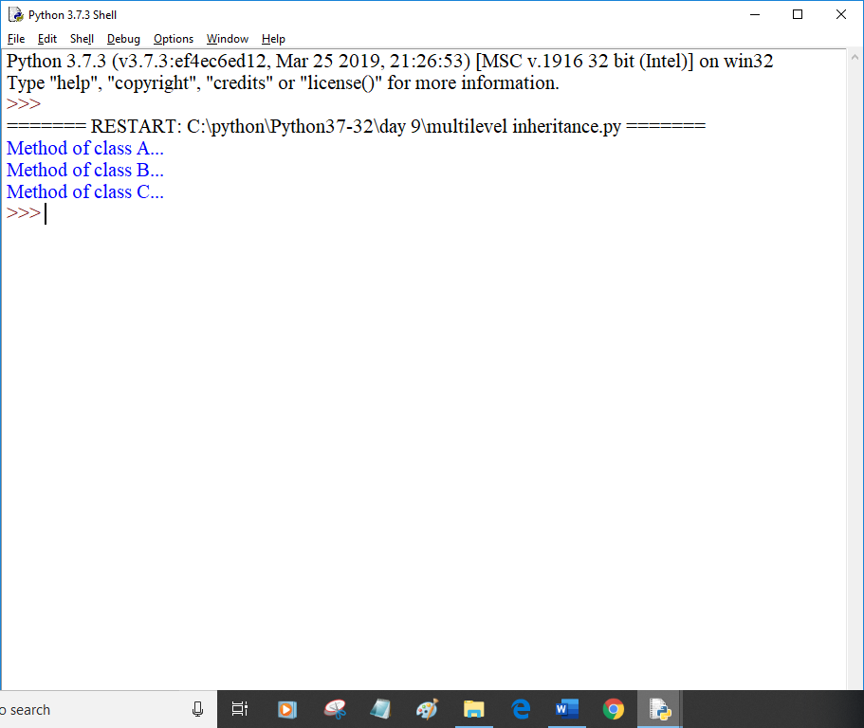

class A:

def first_method(self):

print("Mehtod of class A...")

class B(A):

def first_method(self):

print("Method of class B...")

super().first_method()

ob=B()

ob.first_method()

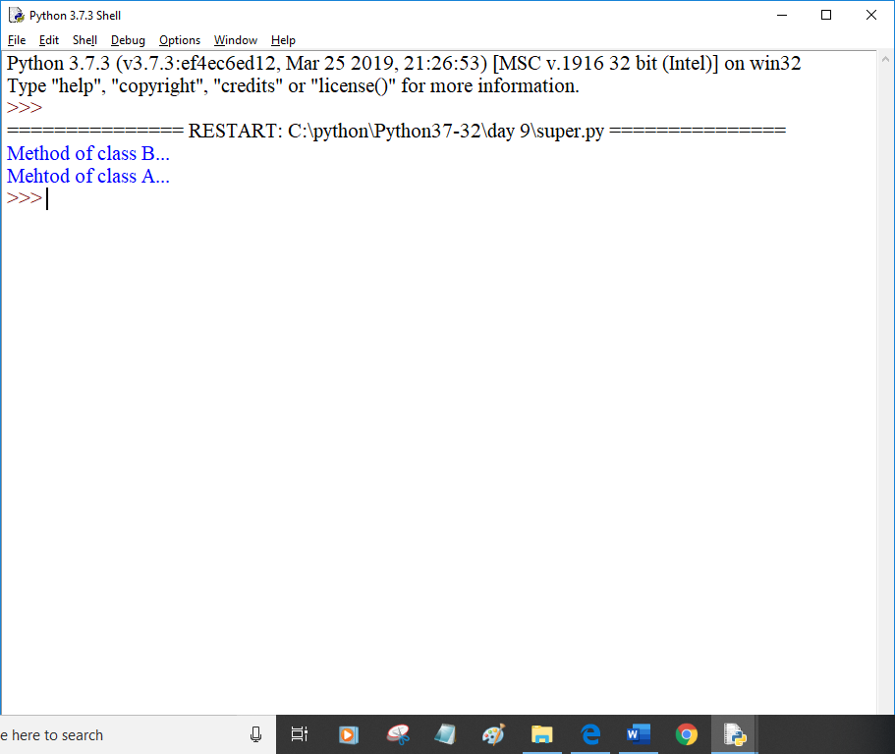

class Employee:

empCount = 0

def __init__(self,name,salary):

self.name=name

self.salary=salary

Employee.empCount +=1

def displayCount(self):

print("Total Employee %d" % Employee.empCount)

def displayEmployee(self):

print("Name",self.name,"Salary",self.salary)

emp1=Employee("Mahima",55000)

print("Total Employee",Employee.empCount)

emp2=Employee("Abhinn",54000)

emp1.displayEmployee()

emp2.displayEmployee()

print("Total Employee %d" % Employee.empCount)

emp3=Employee("Manu Gupta",55500)

emp3.displayCount()

emp2.displayCount()

emp1.displayCount()

print("Total Employee %d" % Employee.empCount)

